http://www.metatags.org/meta_http_equiv_content_type:
HTTP-EQUIV ”CONTENT-TYPE” HTML Tag. What is its meaning
The html meta tag HTTP-EQUIV CONTENT-TYPE allows you to specify the media type (i.e. text/html) and the character set. As different languages have different default character sets, this can be important in ensuring that your page displays correctly in all browsers. So using this meta tag can be very important.
This meta tag has no influence on your ranking with the search engines. But displaying your pages correctly is important to your customers so it will influence how customers will respond and validate your website.
<meta http-equiv="Content-Type" content="text/html">

Example meta tag http-equiv="content-type"

Add the following meta tag in the source of your web-page. The difference in spelling at the end of the tag is either you use " /> = xml or "> = html.
<meta http-equiv="Content-Type" content="text/html; charset=iso-8859-1 ">

Where should you add this Content-Type tag?
You may add this Content-Type meta tag to all of your webpages, so not only in the first index page. Make sure that on every page relevant meta tags are added. Add keywords and phrases that are relevant and correspond to the text and the language on that specific page. It might be a lot of work to add specific meta tags to each page but you will notice in time that it works!

Meta tags Summary - Important SEO things to remember
We suggest that you use the Meta tags in your index.htm or index.html page. Than in all other important pages and last but not least in all the pages of your website. Make sure to put some extra effort in it, it will attract extra visitors to your web-page. Create relevant and different meta tags for each and every page.
- Read why meta tags are important and how they affect the search engines.
- Use our meta tags generator to create the correct meta tags.
- Use our website analyzer to get professional advice from the meta tags experts.
- Submit your website to the search engines and choose one of our packages:
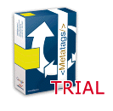 | 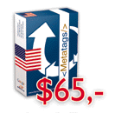 | 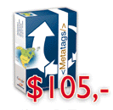 | 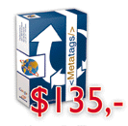
Free Trial | USA Package | North Atlantic Package | World Package

